GCP network reactions to coronavirus and market news

Starting early in March, 2020, the news in US media has been filled with concerns about the coronavirus that was first identified in Wuhan, China. In the US, there were reports on the disruptions overseas, and analysts began warning that there would be worldwide spreading of the COVID-19 virus, much as we have seen with other diseases including SARS and Ebola. In the intervening weeks we have recognized that we are dealing with a pandemic that will likely infect a large proportion of the world population. One of the concomitants of the viral spread is another “viral” effect on the world’s economies, with serious and continuing disruptions of business as usual. A fairly direct indicator of these issues is activity in the stock market which has fluctuated with unusually large changes over the last couple of weeks. The major stock indices including DOW Jones and Standard and Poor have had huge variations, with drops of 5% up to 13% and recoveries of somewhat smaller runs.

The Global Consciousness Project (GCP) network is an instrument designed to capture evidence of a possible interconnection that we think may be fostered by resonant sharing of emotions among large numbers of people. We predict that when events drive people to shared experience and engagement, there will be changes in the data from our network of dozens of random number generators (RNG) around the world. Specifically, our hypothesis is that normally random output from our widely-separated RNG devices will become slightly correlated during “global events” that bring us into resonance. The protocols for experimental tests of this hypothesis depend on identifying sharply defined events, most often an initiating moment (an explosion, an earthquake, an attack) followed by a few hours for the global response to develop via spreading news and communication. A sharply defined event can be distinguished from the mass of other important happenings in our complex world, because they form a background of randomly timed events, against which our rigorously timed event stands out.

Some GCP events are less sharply focused, but still engage millions, for example Earth Day, when people all over the globe gather to promote ecological sanity, or the Kumbh Mela celebration when 10’s of millions gather to bathe away their sins in the Ganges in north India. In such cases we identify the whole UTC day or all the daylight hours. But our instrument – the worldwide network of RNGs – is designed and works well for events of a few hours, and can’t readily be applied to long-lasting turmoil such as the slowly developing coronavirus pandemic. At best we can take samples, preferably when there is a particularly notable moment that represents the general trend.

Many people have asked about the GCP readings of the pandemic, and I have explained that the system isn’t designed to answer that question. But we are curious, of course, and I decided that it might be possible to do some sampling that might provide some indication whether the network is responding. The extreme shifts of the stock market provide a kind of marker, along with news of big changes in attitudes such as the reversals from the White House which is now acknowledging the seriousness of the coronavirus threat. To implement this sampling, I decided to look at the 7-hour long period when the US stock market is open, on several days beginning with March 11 2020. The results are hard to interpret rigorously (and should not be taken as reliable scientific conclusions) but they are interesting, to say the least. In the following pages I show the results for March 11-13, 16, 17. Of the five days, four have strong departures, one upward and three downward. The fifth case shows essentially random data. I provide some contextual notes, but as I have explained, though these graphic representations of “global consciousness” during this period of time may look interesting and suggestive, we do not want to claim they are explicitly meaningful as a representation of our human condition. That remains the domain of our hearts and minds, as we work toward fulfilling our human potentials.

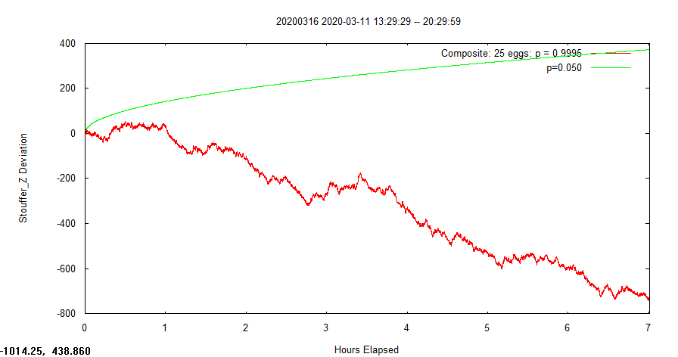
Following is 11th Mar 2020. When I have time later, I will add some notes to help identify things that might relate to the stark departure of the GCP data from normal random expectation.

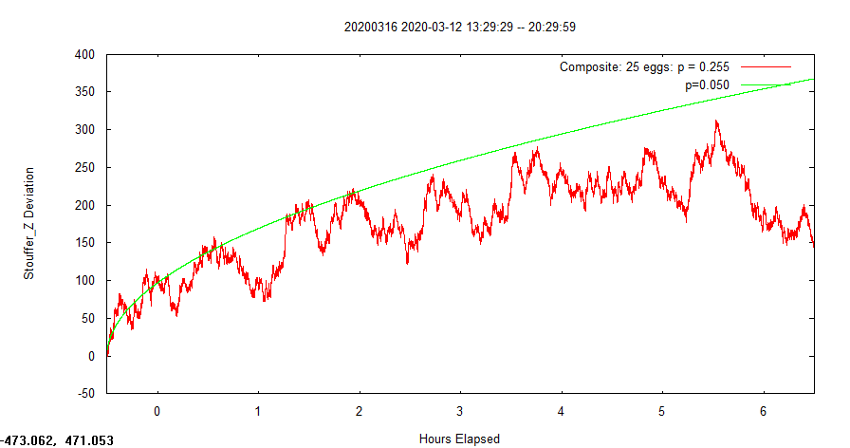
Following is 12th Mar 2020

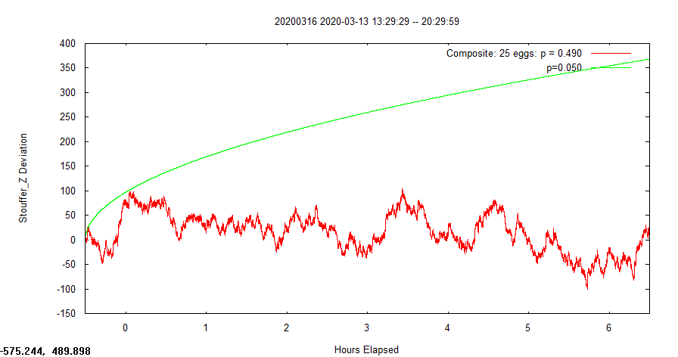
This is 13th Mar 2020

And … the 16th

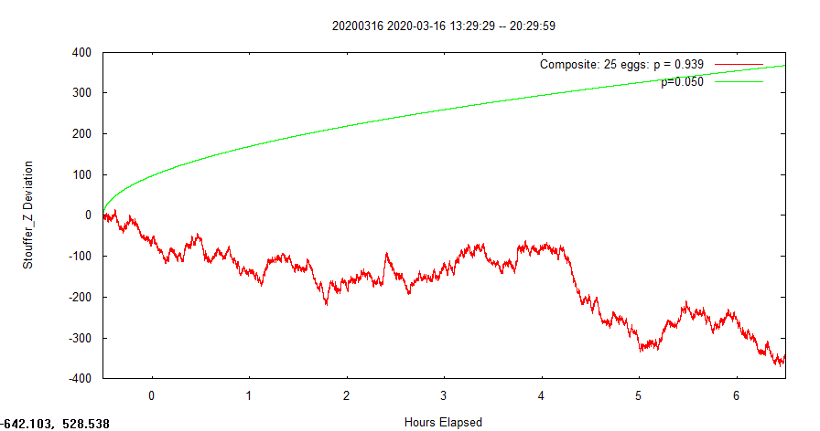

Following is 17th March 2020


